INSTRUCTIONS :
- For each exercise paste the queries executed, below the questions and rename the document with answers to <your_name>_Assignment_Day2.doc. Make sure the answers are in a different readable text color.
- Make it a point to try out all the queries in the slides as well.

With the below tables we will be creating a simple data model holding customer details
CUSTOMERS,CUSTOMER_DETAILS,CUSTOMER_PREFERENCES,PREFERENCES

EX 1: CREATE:
- create the below tables with appropriate data types

CUSTOMERS | PREFERENCES | CUSTOMER_DETAILS | CUSTOMER_PREFERENCES
cust_id | pref_id | create this table selecting all columns from table CUSTOMERS and name the columns as customer_id,customer_name,modified_on and created_on. | cust_id
cust_name | preference |  | pref_id
last_modified | description |  | Active
created_on | last_modified |  | preference_value
 | created_on |  | created_on
 |  |  | last_modified

EX 2: ALTER:

- alter the table CUSTOMER_DETAILS to
drop the below columns
customer_name
modified_on
created_on.
add the below columns
address
phone
DOB
last_modified
created_on

The table should now be as below:
CUSTOMER_DETAILS
customer_id
address
phone
DOB
last_modified
created_on

EX 3: COMMENTS:

- give appropriate comments for all the tables
- How do you view the comments? - give your query
- rename the table CUSTOMER_DETAILS to CUST_DETAILS
- rename the column customer_id in above table to cust_id

EX4 : DCL

Paste in your queries for the below
- create users test_user1 to test_user5. Map them all to a role –TEST_ALL_USERS
- grant insert and update to test_user1 and test_user3.
- Grant alter to all the test_users.

EX 5 :INSERT
- Normalize and Insert the below data into the tables and date can hold current date
cust_id | address | phone | name | DOB (dd.mm.yyyy) | pref_id (all active)
1 | chennai | 100 | Shyam | 14.09.2000 | 1,2,4
2 | bangalore | 200 | ram | 18.02.1989 | 2,3
3 |  | 300 | krishna | 03.11.1987
4 | bangalore |  | vishnu | 10.10.1956 | 1,2,4,5
5 | hyderabad | 500 | aditya | 19.12.1960 | 4,5
6 |  |  | anoop | 07.02.1952 | 7
7 |  | 700 | vidya | 11.07.1977 | 5

pref_id | preference | Description
1 | colour | Favourite colour
2 | food | What kindles the tastebud
3 | car | Car model preferred
4 | brand | Clothes brand preferred
5 | language | Language to subscribe in
6 | authors | Favourite author
- execute the below statement?What happens?
Insert into customer_details values(‘9’,’goa’,’900’);

EX 6:UPDATE
Paste in your queries
- Update all cust_id’s having preference_id 2 in customer_preferences table as inactive
(flag ‘N’).
- Update all phone numbers in customer_details table to begin with 91.If null then ignore.
Eg:100 to 91100
- Update all records having pref_id 2 in customer_preferences table to have created_on date 2 years ago.
Eg: if current date is 04-09-2012 then it must be updated to 04-09-2010.

EX 7:DELETE
Paste in your queries
- Delete all records in customer_preferences table having created_on date before 6 months.

EX 8:MERGE
Create the below table.
Merge the below table with customer_preference table.
set “active” to ‘Y’ if there is a match and if inactive,else ignore.
If it is a new preference for the customer then insert the records.

PREFERENCE_UPDATE
CUST_ID | PREF_ID
1 | 5,2
4 | 6
7 | 4,2
2 | 2

EX 9:FUNCTIONS
Paste in your queries.
- Select all cust_id’s who have address or phone as NULL in customer_details table.
- Select and display all the unique address locations from customer_details table.
- Display data from customer_details table and if address is NULL display ‘TBD’, if phone is null display ‘000’.
- Display cust_id’s that have opted to preference 4 and are active using where exists function from customer_preferences table.
- Display only the cust_id in order of their created_on dates from customers table.
- Is the BETWEEN keyword inclusive ?

EX 10 :TCL
- Update ‘shyam’ to ‘sohan’ in the customers table and don’t commit
- Create a savepoint say ‘LABELA’
- Update ‘sohan’ to ‘rohan’ in the customers table and don’t commit
- Create a savepoint say ‘LABELB’
- Rollback to LABELA
- Update the last name sohan/shyam or rohan to mohan
- Create a savepoint say ‘LABELC’
- Commit;
- Rollback to LABELB.
- Observe the changes.
EX 11 : Constraints

- In employee table , The emp_id needs to have only distinct values , emp_name should be not null and the salary of each employee should not exceed 100000. What kind of constraints should be created in these columns?
- In employee table , The emp_id should be distinct and not null. What kind of constraint should be created for this Business rule ?
- Create a referential integrity between employees and department table based on department_id.
- Delete the department 102 from departments table.
- Can a foreign key and primary key be created on the same column? If so give some example

Other Exercises :

- Bring out the below model with the help of the SQL statements covered so far.
Please enter some sample data to work with .
Paste in the queries used.

ALL the tables can be renamed with TKT_ prefix in case the objects already exist.

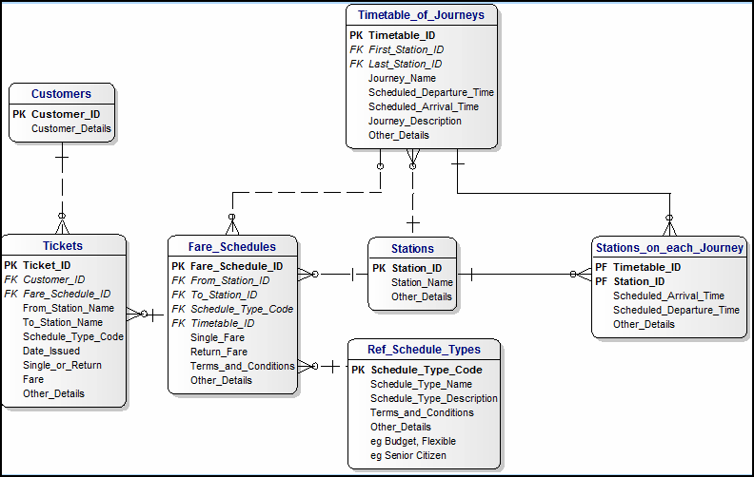
NOTE:
PK:Primary Key
FK:foreign key
PF:primary/foreign key

- Create 10 users from user1 to user10 and grant all permissions on CUSTOMERS table to all of them. Also grant all permissions on TICKETS table for user1 to user5.
- Display the number of null values in the address column of customer_details table.
- Using the data model created in the in Ex-1. Do the following:
- Display the number of preferences that each member has.
- Display the number of members across preferences and address and display the preference,preference_id,count and address
- Update all the pref_id in the table to 4.
- Revert the changes so that the data is displayed as it used to be

- Present the below list to your trainer with the use and usage of the function.with query examples.

List Of Functions:
- Length
- Concat
- Upper
- Lower
- Initcap
- Least,greatest,first
- Mod
- SysDate
- Current_date
- MONTHS_BETWEEN
- NEXT_DAY

